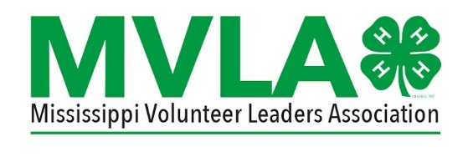
Mississippi 4-H Volunteer Leaders’ Association
Kenneth Cook Award Nomination Form
The Kenneth Cook Award was established to recognize Extension employees who have gone the ‘extra mile’ and demonstrated strong support for the Mississippi 4-H Volunteer Leaders' Association and 4-H Volunteers across the state. The recipient is selected by the MVLA Board.
Nominator’s name (must be a MVLA Board Member: ________________________________
Name of Extension employee being nominated:_____________________________________
Nominee’s Job Title:__________________________________________________________________
What Extension region does the employee work in? ________________________________
In 50 words or less explain why this Extension employee is deserving of this award. Please provide examples of how they have provided support to the Mississippi 4-H Volunteer Leaders’ Association.
The nominator is responsible for providing a bio for the award recipient no later than February 23, 2024. Send to Lisha Hopper at hopperlisha@hotmail.com.

